UK results:
First, dks are correlated with age, and with age sq:
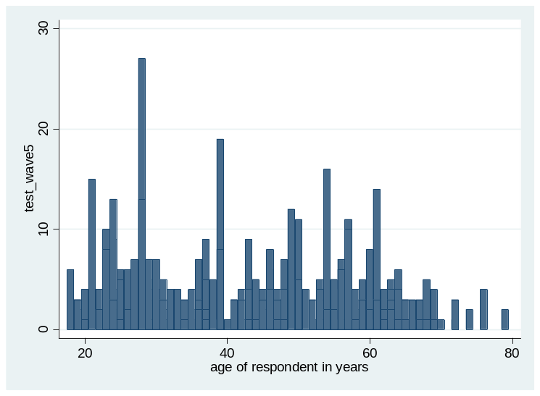

Second, there seems to be a connection with gender:

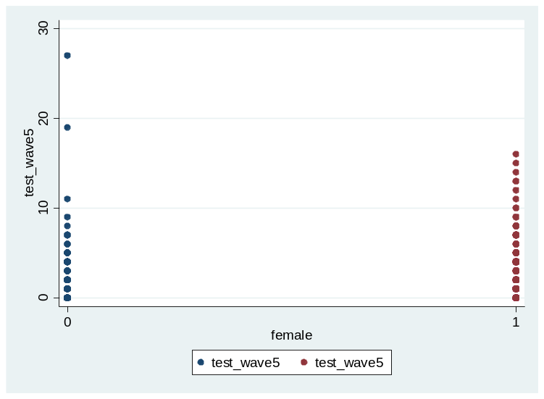

Correlations:
The correlation with age is -0.20, the correlation with age square is a bit lower, -0.19, all significant (N=762). The correlation with gender (female) is .19 (same N=762). Age and female explain a small but significant variation in the pattern of DKs (about 4% each).
The pattern of DKs is not correlated with education.

How it affects responses

 | Variable text | Correlation with  Number of DKs at pre-election wave | N
Responses at post-election wave | General Election: Interest  (inverse coding)  w6_p10050q1 | 0.4486 | 582
Responses at post-election wave | General Election: Voting turnout history | 0.3272 | 575
Responses at post-election wave | Satisfaction with Democracy | 0.0467 | 567
Responses at post-election wave | Interest in politics (v1)  w6_p830q1 | 0.4447 | 579
Responses at post-election wave | Interested in politics (v2)  w6_p1130q1 | 0.3852 | 574

Distributions, not weighted, weighted by the DK variable, weighted by “interest” variable at pre-election wave:

Interest in general election

 | Not weighted | Interest in politics  (Pre-election) | DK variable
very interested | 59.62 | 49.64 | 43.92
somewhat interested | 29.90 | 34.84 | 31.60
not very interested | 7.39 | 10.99 | 14.26
not at all interested | 3.09 | 4.53 | 10.21
N | 582 | 582.01 | 582.02

The correlation between pre-election reported interest in politics and post-election wave reported interest in the general election is .58. This is higher than the correlation with the DK responses, but not so much higher, because this one is .45.
The basic point of the table above is that even if we want to check consistency of responses across waves, using a variable which we know is correlated with the other; we are likely to get a more accurate estimate if we just look at the dk variable.
Analysis
[here, run the models with the interest variables; perhaps even just the demographic model]

Table 1.
 | DV: Reported turnout
 | Not weighted | DK weight
Age | .0405864  .0406834 | .0392855  .0348621
z_{Age} | 1.00 | 1.13
Age square | -.0001038  .0004361 | .0000601  .0003879
z_{Age_sq} | -0.24 | 0.16
Education | .1838401  .0696891 | .2026776  .0600864
z_{Education} | 2.64 | 3.37
Constant | -.8311827  1.012465 | -1.602336  .8515758
z_{Constant} | -0.82 | -1.88
Pseudo R | 0.0736 | 0.1224
Chi square | 21.99 | 62.07
Log-likelihood | -138.49 | -222.43992
 | 564 | 564
Note. Probit results. The analysis using the survey-provided weight variable did not perform significantly better than the not weighted analysis, and therefore the results are not included for space concerns. Available from the author.

Table 2.
 | DV: Reported turnout
 |  |  | Not weighted | DK weight
Interest in politics (Post-election) | -.4706657  .1040547 | -.4558973  .0845779
z | -4.52 | -5.39
Interest in election
Z
Habitual voter
Z
Age | .0511755  .0436767 | .0768986  .0384967
z_{Age} | 1.17 | 2.00
Age square | -.0002814  .0004678 | -.0004425  .0004267
z_{Age_sq} | -0.60 | -1.04
Education | .1602577  .0747402 | .2160711  .0654191
z_{Education} | 2.14 | 3.30
Constant | .3010023  1.106631 | -.9006357  .9488075
z_{Constant} | 0.27 | -0.95
Pseudo R | 0.1463 | 0.1832
Chi square | 42.18 | 81.74
Log-likelihood | -123.08127 | -182.25349
N | 561 | 561

